

**UNITED INTERNATIONAL UNIVERSITY**

LAB REPORT- 06

Course Name: Control System Laboratory

Course Code: EEE 402/ EEE 4110 (A)

**Submitted To;**

RAHMAN, KALED MASUKUR

PROFESSOR

UIU

**Submitted By;**

Name: Monisha Roy

ID: 021-182-031

Name: Joyanta Debnath

ID: 021-182-032

Date of Submission:

**Experiment Name:** Design a PID Controller using Root Locus Method and SISO design tool.

**Objective:**

* Understanding PID Controller.
* Familiarity with Root Locus Method.
* SISO Design Tool Proficiency.
* Plant Modeling and Transfer Functions.
* Engineering Decision-Making Skills.
* Physical realization of PID Compensation.

**Design Requirement:** Given, a unity feedback system is working at 20% overshoot with the following Transfer-function;

And, H(s)=1. The PID controller should meet the following criteria;

1. Compensated peak time = ⅔ of uncompensated peak time
2. % OS = 20% and
3. Steady-state error = 0

**(i)Uncompensated condition**; Plant and compensator=; Dominant Poles at, -5.42±j10.6

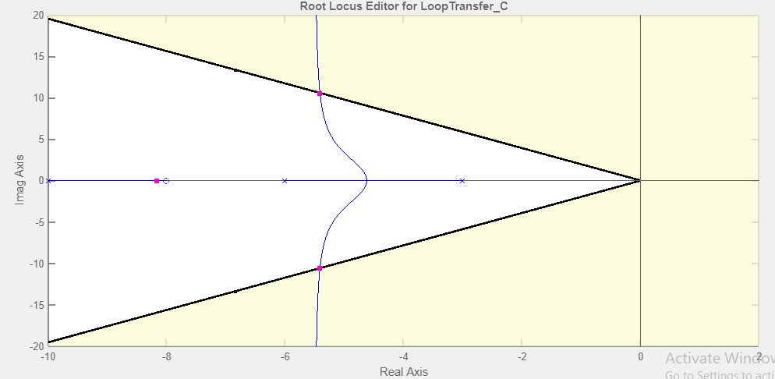

|  |  |  |  |  |  |  |  |  |  |
| --- | --- | --- | --- | --- | --- | --- | --- | --- | --- |
| K | ζ | ωn | %OS | Ts | Tp | Kp | e(∞) | Other Poles | Zeros |
| 121.53 | 0.456 | 11.9 | 20.7 | 0.7 | 0.298 | 5.4 | 0.156 | -8.17 | -8 |

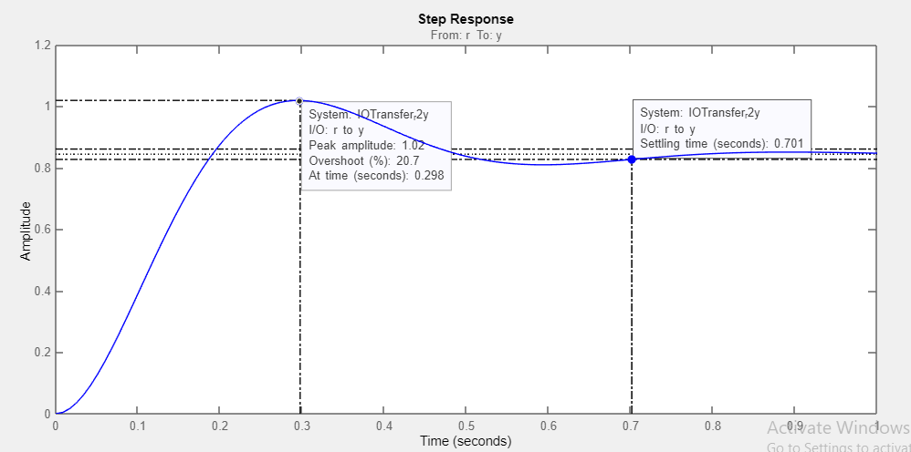

**(ii)PD-Compensated condition:** Plant and compensator=; Dominant Poles at, -8.1+j15.8

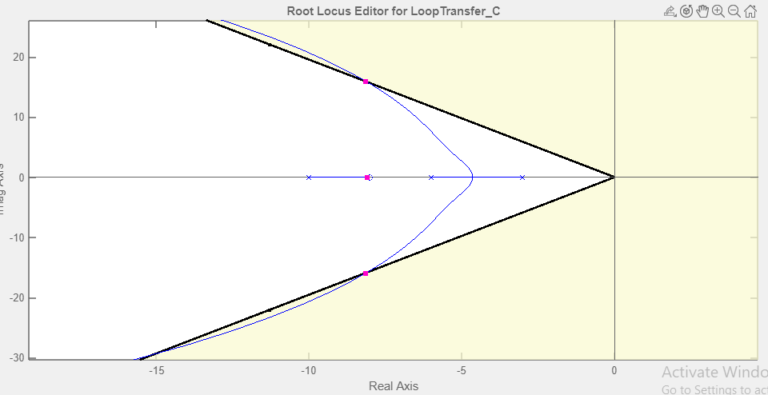

|  |  |  |  |  |  |  |  |  |  |
| --- | --- | --- | --- | --- | --- | --- | --- | --- | --- |
| K | ζ | ωn | %OS | Ts | Tp | Kp | e(∞) | Other Poles | Zeros |
| 5.28 | 456 | 17.8 | 21.8 | 0.449 | 0.176 | 13.15 | 0.070 | -8.08 | -8,-56.1 |

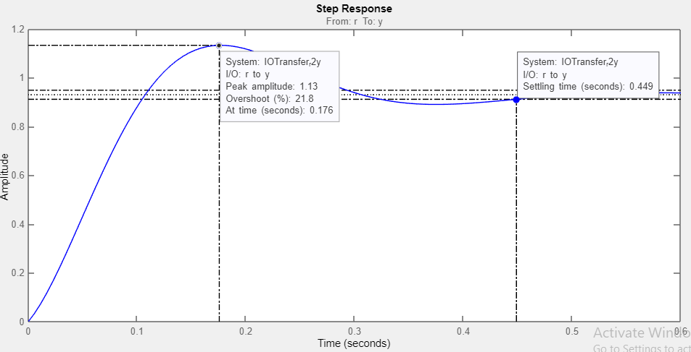

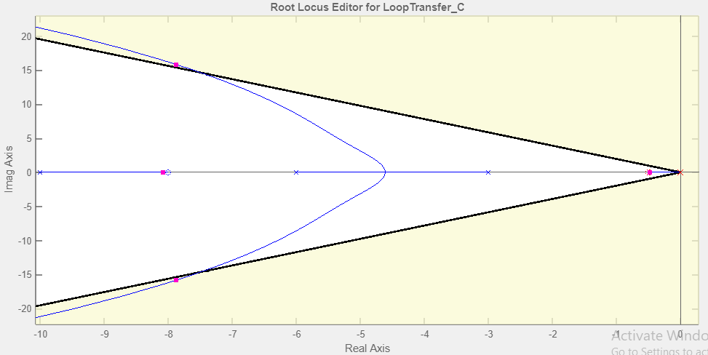**(iii)PID-Compensated condition:** Plant and compensator=

|  |  |  |  |  |  |  |  |  |  |
| --- | --- | --- | --- | --- | --- | --- | --- | --- | --- |
| K | ζ | ωn | %OS | Ts | Tp | Kp | e(∞) | Other Poles | Zeros |
|  |  |  | 16.1 | 2.24 | 0.181 | Kv= infinit | 0 |  |  |

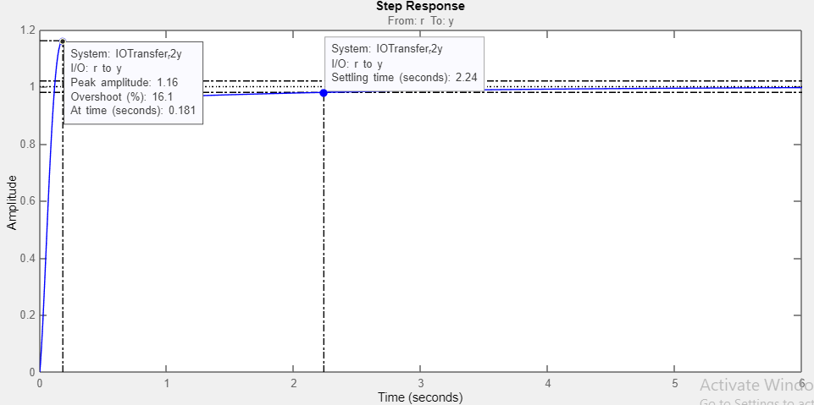

**PID Controller: PID Gp**

+

-

**Discussion:**

* **%OS change in PID**: Here we can see maximum deviation of the system's response from its steady-state values. Increasing Kp tends to increase the percent overshoot and minimizes Ts in PD compensation. Moreover, in PID compensation following the third pole domination, it is hard to maintain required %OS, thus vivid increase in Ts has been noticed. In terms of pole-zero cancellation, we have to put the zero nearer to the origin to cancel out the effect of pole located in origin.
* **Acceptability**: Weather or not this PID compensator is accepted, is highly dependent on the application of the controller. Although, Ts is much higher in PID compensation but in terms of response, PI compensation is faster than PD.
* **Trial and Error**: As we failed to maintain required %OS, in terms of pole-zero cancellation, we have to amend the zero of PI compensator so that we can find precise values to complement the given criteria.

**Physical realization of PID:** Using the following formula from PID; 

Using the values of compensated zeros, poles and this gain, we can calculate;



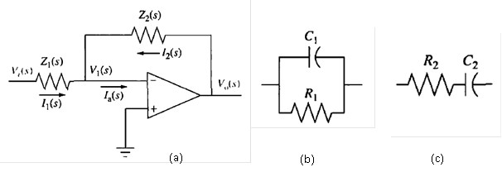

1. Circuit for PID

$Z_{1}(s)$

$Z_{2}(s)$

Now, PID= $\frac{5.28(s+56.1)(s+0.5)}{s}$ = $5.28s+298.484+\frac{148.104}{s}$

So, $\frac{R_{2}}{R_{1}}+\frac{C_{1}}{C_{2}}$ = 298.484 ; $R_{2}C_{1}$ = 5.28 ; $\frac{1}{R_{1}C_{2}}$ = 148.104

Let, $C_{1}$ = 1µF ; $R_{2}$ = 5.28MΩ

Similarly, $C_{2}$ =5µF ; $R_{1}$ =1.35KΩ